Top 50 FAANG-Level System Design Projects — HLD + LLD + Complete Technology Stack
To prepare for Data Engineering, Data Science, and Software Engineering interviews at Google, Amazon, Meta, Apple, and Netflix, you should build projects that demonstrate not just coding, but how to design, implement, scale, secure, monitor, and maintain an entire system.
The goal is to learn HLD (High-Level Design), LLD (Low-Level Design), distributed systems, databases, APIs, cloud infrastructure, data pipelines, and production engineering through practical projects.
These 50 projects are organized from beginner to advanced. The selection covers common system-design interview problems and the underlying skills they test, including caching, replication, partitioning, event streaming, fault tolerance, and API design.

GitHub
+2
One important distinction: these are FAANG-level practice projects, not official FAANG company specifications. You can build realistic, production-inspired versions locally without purchasing cloud services.
1. What HLD and LLD mean in a real project
HLD — High-Level Design
The system architecture: how all the major components communicate.
- Requirements, traffic estimates and capacity planning
- Client, API gateway, services and communication protocols
- SQL/NoSQL databases, cache, queues and object storage
- Replication, sharding, consistency and availability
- Deployment, security, scaling and disaster recovery
LLD — Low-Level Design
The implementation blueprint: how individual components are designed in code.
- Classes, interfaces, modules and their relationships
- Database tables, keys, indexes and constraints
- API request/response schemas and validation
- Design patterns, SOLID principles and error handling
- Unit tests, concurrency control and business rules
For example, a URL shortener's HLD determines that requests pass through a load balancer, API service, Redis cache and database. Its LLD defines classes such as URLService, URLRepository, ShortCodeGenerator and RedirectHandler, including their methods and error handling.
Every project below should include both designs.
2. Top 50 projects by difficulty
Recommended sequence for a learner starting with Python and SQL. Start locally, then add distributed infrastructure as your understanding improves.
Explore the 50-project catalogue
AllBeginnerIntermediateAdvanced
All
Showing 50 of 50 projects
1
URL Shortener
Beginner
Backend
Hashing, redirects, cache-aside
Stack: Python, FastAPI, PostgreSQL, Redis, Docker
Build this project
2
Rate Limiter Service
Beginner
Backend
Token bucket, sliding window, concurrency
Stack: Python, FastAPI, Redis, pytest, Docker
Build this project
3
Parking Lot Management
Beginner
Backend
OOP, SOLID, state transitions
Stack: Python, dataclasses, enums, SQLite, pytest
Build this project
4
Library Management System
Beginner
Backend
Domain models, reservations, transactions
Stack: Python, FastAPI, PostgreSQL, SQLAlchemy
Build this project
5
Expense Tracking Service
Beginner
Backend
REST, validation, reporting
Stack: Python, FastAPI, PostgreSQL, Pydantic
Build this project
6
Notification Service
Beginner
Backend
Queues, retries, idempotency
Stack: Python, FastAPI, RabbitMQ, PostgreSQL
Build this project
7
File Storage Service
Beginner
Infrastructure
Metadata, uploads, object storage
Stack: Python, FastAPI, MinIO, PostgreSQL
Build this project
8
API Gateway and Load Balancer Simulator
Beginner
Infrastructure
Routing, health checks, round robin
Stack: Python, FastAPI, httpx, pytest
Build this project
9
Inventory Management System
Beginner
Commerce
Stock consistency, reservations, transactions
Stack: Python, FastAPI, PostgreSQL, Redis
Build this project
10
Job Queue and Task Scheduler
Beginner
Data Engineering
Background jobs, retries, dead letters
Stack: Python, Celery, Redis, PostgreSQL
Build this project
11
E-commerce Backend
Intermediate
Commerce
Catalog, carts, orders, service boundaries
Stack: FastAPI, PostgreSQL, Redis, Docker
Build this project
12
Food Delivery Platform
Intermediate
Commerce
Order state machine, dispatch, location updates
Stack: FastAPI, PostgreSQL, Redis, WebSockets
Build this project
13
Ride-Hailing System
Intermediate
Commerce
Geospatial search, matching, trip lifecycle
Stack: Python, PostGIS, Redis, WebSockets
Build this project
14
Hotel and Room Booking
Intermediate
Commerce
Concurrent reservations, preventing double booking
Stack: FastAPI, PostgreSQL, transactions, Redis
Build this project
15
Payment Processing Simulator
Intermediate
Backend
Idempotency, ledger, reconciliation
Stack: Python, FastAPI, PostgreSQL, RabbitMQ
Build this project
16
Chat and Messaging System
Intermediate
Realtime
WebSockets, delivery receipts, offline messages
Stack: FastAPI, WebSockets, Redis, PostgreSQL
Build this project
17
Social Media News Feed
Intermediate
Realtime
Fan-out on write/read, feed ranking
Stack: FastAPI, PostgreSQL, Redis, Kafka
Build this project
18
Video Upload and Streaming Platform
Intermediate
Realtime
Chunked upload, transcoding, CDN concepts
Stack: Python, MinIO, FFmpeg, Celery
Build this project
19
Search Autocomplete Engine
Intermediate
Infrastructure
Trie, prefix index, ranking
Stack: Python, FastAPI, Redis, Elasticsearch
Build this project
20
Distributed Cache
Intermediate
Infrastructure
Eviction, TTL, cache invalidation
Stack: Python, Redis, FastAPI, pytest
Build this project
21
Web Crawler and Indexer
Intermediate
Infrastructure
URL frontier, deduplication, politeness
Stack: Python, asyncio, Kafka, Elasticsearch
Build this project
22
Distributed Logging Platform
Intermediate
Infrastructure
Ingestion, indexing, retention, alerts
Stack: Python, Kafka, OpenSearch, Grafana
Build this project
23
Real-Time Analytics Dashboard
Intermediate
Data Engineering
Streaming aggregation, event time
Stack: Kafka, Python, Flink, PostgreSQL, Streamlit
Build this project
24
ETL/ELT Pipeline Platform
Intermediate
Data Engineering
Orchestration, lineage, incremental loads
Stack: Python, Airflow, PostgreSQL, MinIO
Build this project
25
Data Quality Monitoring Service
Intermediate
Data Engineering
Schema checks, freshness, anomaly alerts
Stack: Python, Pandera, Airflow, PostgreSQL
Build this project
26
Distributed Message Queue
Intermediate
Infrastructure
Partitions, offsets, consumer groups
Stack: Kafka, Python, Docker, Prometheus
Build this project
27
Feature Flag Service
Intermediate
Backend
Rules, gradual rollout, local caching
Stack: FastAPI, PostgreSQL, Redis, pytest
Build this project
28
Multi-Tenant SaaS Platform
Intermediate
Backend
Tenant isolation, quotas, authorization
Stack: FastAPI, PostgreSQL, Redis, JWT
Build this project
29
Collaborative Document Editor
Intermediate
Realtime
Concurrent edits, OT/CRDT concepts
Stack: Python, WebSockets, Redis, PostgreSQL
Build this project
30
Recommendation Engine
Intermediate
AI/ML
Candidate retrieval, ranking, feedback
Stack: Python, pandas, scikit-learn, FastAPI, Redis
Build this project
31
Distributed Key-Value Store
Advanced
Infrastructure
Consistent hashing, replication, quorum
Stack: Python, asyncio, gRPC, Docker
Build this project
32
Object Storage System
Advanced
Infrastructure
Multipart uploads, replication, metadata
Stack: Python, MinIO, PostgreSQL, Docker
Build this project
33
Distributed Web Crawler at Scale
Advanced
Infrastructure
Partitioned frontier, leases, deduplication
Stack: Python, Kafka, Redis, object storage
Build this project
34
Global Notification Platform
Advanced
Realtime
Multi-channel fan-out, rate limits, delivery tracking
Stack: Kafka, Python, Redis, PostgreSQL
Build this project
35
Real-Time Fraud Detection
Advanced
AI/ML
Streaming features, thresholds, model serving
Stack: Kafka, Flink, scikit-learn, FastAPI
Build this project
36
Distributed Data Processing Engine
Advanced
Data Engineering
Partitions, workers, retries, shuffle
Stack: Python, PySpark, MinIO, Docker
Build this project
37
Data Warehouse and Lakehouse
Advanced
Data Engineering
Bronze/silver/gold, schema evolution, compaction
Stack: PySpark, Parquet, Iceberg concepts, MinIO
Build this project
38
Ad Click Aggregation and Billing
Advanced
Data Engineering
Deduplication, event time, exactly-once effects
Stack: Kafka, Flink, PostgreSQL, Prometheus
Build this project
39
Metrics and Alerting Platform
Advanced
Infrastructure
Time-series ingestion, aggregation, alert evaluation
Stack: Python, Prometheus, Grafana, PostgreSQL
Build this project
40
Distributed Task Orchestrator
Advanced
Data Engineering
DAG execution, retries, leases, recovery
Stack: Python, FastAPI, PostgreSQL, Redis, Docker
Build this project
41
Search Engine
Advanced
Infrastructure
Crawling, inverted indexes, relevance ranking
Stack: Python, Kafka, OpenSearch, Redis
Build this project
42
Global E-commerce Marketplace
Advanced
Commerce
Catalog, pricing, stock, orders, sagas
Stack: FastAPI, Kafka, PostgreSQL, Redis
Build this project
43
Multi-Region Payment Ledger
Advanced
Backend
Double-entry accounting, reconciliation, consistency
Stack: Python, PostgreSQL, Kafka, Docker
Build this project
44
Maps and Route Planning
Advanced
Infrastructure
Graph routing, geospatial indexes, traffic updates
Stack: Python, NetworkX, PostGIS, Redis
Build this project
45
Video Recommendation and Delivery
Advanced
AI/ML
Recommendation, transcoding, CDN, playback analytics
Stack: Python, Kafka, PySpark, MinIO, FastAPI
Build this project
46
LLM-powered RAG Platform
Advanced
AI/ML
Chunking, retrieval, reranking, evaluation
Stack: Python, FastAPI, PostgreSQL/pgvector, Ollama
Build this project
47
Feature Store and ML Serving
Advanced
AI/ML
Offline/online features, freshness, model monitoring
Stack: Python, Kafka, Feast concepts, PostgreSQL, FastAPI
Build this project
48
Real-Time Inventory and Price Comparator
Advanced
Data Engineering
Multi-source ingestion, SKU matching, freshness
Stack: Python, Playwright, PostgreSQL, Kafka, Streamlit
Build this project
49
Large-Scale Data Lake Ingestion Service
Advanced
Data Engineering
Backpressure, schema registry, replay, data contracts
Stack: Kafka, PySpark, Parquet, MinIO, Airflow
Build this project
50
Planet-Scale Event Analytics Platform
Advanced
Data Engineering
High-throughput events, aggregation, retention, recovery
Stack: Kafka, Flink, object storage, warehouse, Grafana
Build this project
3. The complete toolset to learn
You do not need to master every technology before beginning. Learn the shared foundations first, then introduce advanced infrastructure only when the project needs it.

1. Programming and LLD
Python, OOP, type hints, dataclasses, SOLID, design patterns, pytest, Pydantic.
Use these to implement services, business rules, validation, interfaces, and unit tests.
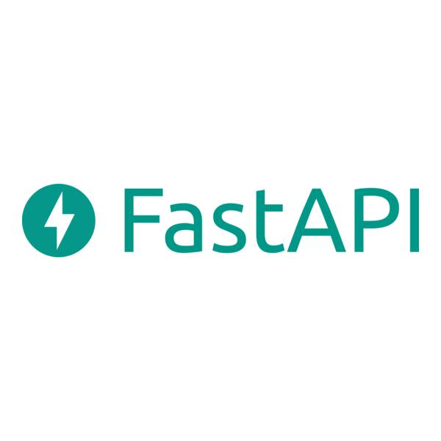
2. APIs and communication
FastAPI, REST, HTTP/HTTPS, JSON, OpenAPI, WebSockets, gRPC, OAuth 2.0/JWT.
Learn request validation, authentication, pagination, versioning, timeouts, retries, and error codes.

3. Databases and storage
PostgreSQL, SQLite, Redis, MongoDB, Elasticsearch/OpenSearch, S3-compatible MinIO, Parquet.
Master schema design, indexes, transactions, query plans, caching, partitioning, replication, and data retention.

4. Messaging and distributed processing
Kafka, RabbitMQ, Celery, PySpark, Apache Flink, Airflow.
Learn event-driven architecture, partitions, consumer groups, offsets, event-time processing, retries, replay, and idempotency.

5. Deployment and infrastructure
Docker, Docker Compose, Kubernetes, Nginx, Terraform, GitHub Actions, Linux/WSL.
Learn containerization, load balancing, health checks, CI/CD, rolling deployment, secrets, and infrastructure as code.
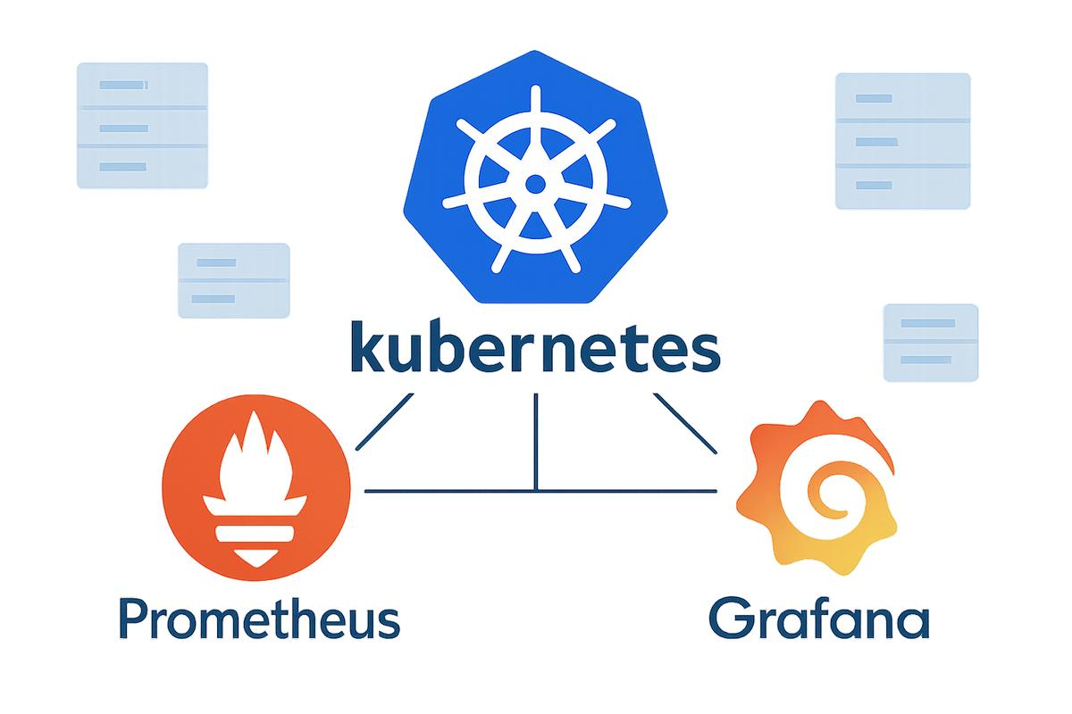
6. Observability and reliability
Prometheus, Grafana, OpenTelemetry, structured logs, pytest, Locust.
Track latency, throughput, error rates, saturation, traces, alerts, service-level objectives (SLOs), and recovery.
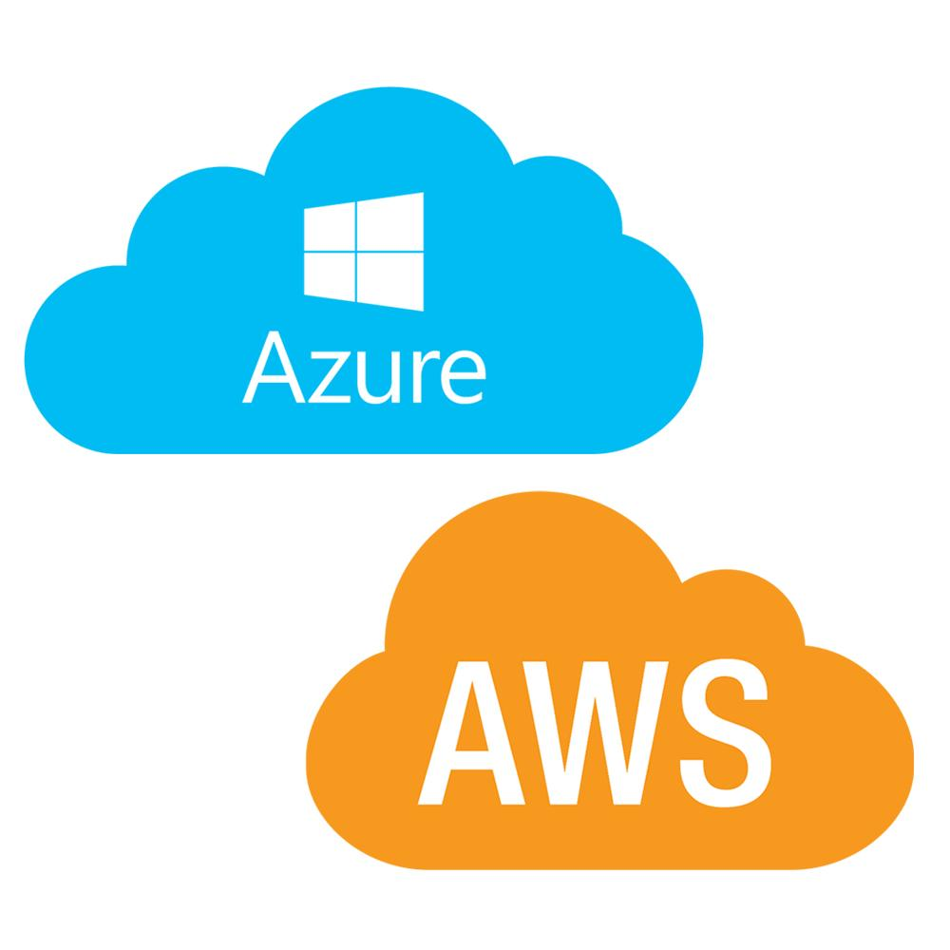
7. Cloud and security
AWS or Azure, IAM, TLS, encryption, secret management, VPC/networking, object storage.
Start locally. Then deploy selected projects to one cloud, learning cost management and least-privilege access.
These are possible implementation choices, not a requirement to use every tool in every project. Choose technologies according to the problem rather than adding them just to make the architecture look complex.
4. HLD deliverables for every project
Each project should have a docs/hld.md file containing these sections.
Section | What you must document
Requirements | Functional and non-functional requirements
Scale | Users, requests/sec, data volume, read/write ratio
Architecture | Components and communication paths
APIs | Endpoints, methods, payloads and status codes
Storage | Database selection, schema, indexes and retention
Scaling | Caching, partitioning, replication and load balancing
Reliability | Timeouts, retries, failover, backups and recovery
Security | Authentication, authorization, encryption and secrets
Trade-offs | Why your architecture is preferable to alternatives
Operations | Metrics, logs, alerts, deployment and cost estimates
A basic HLD diagram should show the flow of a request, not simply a collection of technology logos.
#chatgpt-mermaid-_r_pr_{font-family:-apple-system-body,ui-sans-serif,-apple-system,system-ui,"Segoe UI",Helvetica,"Apple Color Emoji",Arial,sans-serif,"Segoe UI Emoji","Segoe UI Symbol";font-size:16px;fill:rgb(13, 13, 13);}@keyframes edge-animation-frame{from{stroke-dashoffset:0;}}@keyframes dash{to{stroke-dashoffset:0;}}#chatgpt-mermaid-_r_pr_ .edge-animation-slow{stroke-dasharray:9,5!important;stroke-dashoffset:900;animation:dash 50s linear infinite;stroke-linecap:round;}#chatgpt-mermaid-_r_pr_ .edge-animation-fast{stroke-dasharray:9,5!important;stroke-dashoffset:900;animation:dash 20s linear infinite;stroke-linecap:round;}#chatgpt-mermaid-_r_pr_ .error-icon{fill:rgb(243, 243, 243);}#chatgpt-mermaid-_r_pr_ .error-text{fill:rgb(13, 13, 13);stroke:rgb(13, 13, 13);}#chatgpt-mermaid-_r_pr_ .edge-thickness-normal{stroke-width:1px;}#chatgpt-mermaid-_r_pr_ .edge-thickness-thick{stroke-width:3.5px;}#chatgpt-mermaid-_r_pr_ .edge-pattern-solid{stroke-dasharray:0;}#chatgpt-mermaid-_r_pr_ .edge-thickness-invisible{stroke-width:0;fill:none;}#chatgpt-mermaid-_r_pr_ .edge-pattern-dashed{stroke-dasharray:3;}#chatgpt-mermaid-_r_pr_ .edge-pattern-dotted{stroke-dasharray:2;}#chatgpt-mermaid-_r_pr_ .marker{fill:rgb(143, 143, 143);stroke:rgb(143, 143, 143);}#chatgpt-mermaid-_r_pr_ .marker.cross{stroke:rgb(143, 143, 143);}#chatgpt-mermaid-_r_pr_ svg{font-family:-apple-system-body,ui-sans-serif,-apple-system,system-ui,"Segoe UI",Helvetica,"Apple Color Emoji",Arial,sans-serif,"Segoe UI Emoji","Segoe UI Symbol";font-size:16px;}#chatgpt-mermaid-_r_pr_ p{margin:0;}#chatgpt-mermaid-_r_pr_ .label{font-family:-apple-system-body,ui-sans-serif,-apple-system,system-ui,"Segoe UI",Helvetica,"Apple Color Emoji",Arial,sans-serif,"Segoe UI Emoji","Segoe UI Symbol";color:rgb(13, 13, 13);}#chatgpt-mermaid-_r_pr_ .cluster-label text{fill:rgb(13, 13, 13);}#chatgpt-mermaid-_r_pr_ .cluster-label span{color:rgb(13, 13, 13);}#chatgpt-mermaid-_r_pr_ .cluster-label span p{background-color:transparent;}#chatgpt-mermaid-_r_pr_ .label text,#chatgpt-mermaid-_r_pr_ span{fill:rgb(13, 13, 13);color:rgb(13, 13, 13);}#chatgpt-mermaid-_r_pr_ .node rect,#chatgpt-mermaid-_r_pr_ .node circle,#chatgpt-mermaid-_r_pr_ .node ellipse,#chatgpt-mermaid-_r_pr_ .node polygon,#chatgpt-mermaid-_r_pr_ .node path{fill:rgb(222, 234, 251);stroke:rgb(83, 154, 248);stroke-width:1px;}#chatgpt-mermaid-_r_pr_ .rough-node .label text,#chatgpt-mermaid-_r_pr_ .node .label text,#chatgpt-mermaid-_r_pr_ .image-shape .label,#chatgpt-mermaid-_r_pr_ .icon-shape .label{text-anchor:middle;}#chatgpt-mermaid-_r_pr_ .node .katex path{fill:#000;stroke:#000;stroke-width:1px;}#chatgpt-mermaid-_r_pr_ .rough-node .label,#chatgpt-mermaid-_r_pr_ .node .label,#chatgpt-mermaid-_r_pr_ .image-shape .label,#chatgpt-mermaid-_r_pr_ .icon-shape .label{text-align:center;}#chatgpt-mermaid-_r_pr_ .node.clickable{cursor:pointer;}#chatgpt-mermaid-_r_pr_ .root .anchor path{fill:rgb(143, 143, 143)!important;stroke-width:0;stroke:rgb(143, 143, 143);}#chatgpt-mermaid-_r_pr_ .arrowheadPath{fill:rgb(143, 143, 143);}#chatgpt-mermaid-_r_pr_ .edgePath .path{stroke:rgb(143, 143, 143);stroke-width:1px;}#chatgpt-mermaid-_r_pr_ .flowchart-link{stroke:rgb(143, 143, 143);fill:none;}#chatgpt-mermaid-_r_pr_ .edgeLabel{background-color:rgb(252, 252, 252);text-align:center;}#chatgpt-mermaid-_r_pr_ .edgeLabel p{background-color:rgb(252, 252, 252);}#chatgpt-mermaid-_r_pr_ .edgeLabel rect{opacity:0.5;background-color:rgb(252, 252, 252);fill:rgb(252, 252, 252);}#chatgpt-mermaid-_r_pr_ .labelBkg{background-color:rgba(252, 252, 252, 0.5);}#chatgpt-mermaid-_r_pr_ .cluster rect{fill:rgb(243, 243, 243);stroke:rgba(0, 0, 0, 0.1);stroke-width:1px;}#chatgpt-mermaid-_r_pr_ .cluster text{fill:rgb(13, 13, 13);}#chatgpt-mermaid-_r_pr_ .cluster span{color:rgb(13, 13, 13);}#chatgpt-mermaid-_r_pr_ div.mermaidTooltip{position:absolute;text-align:center;max-width:200px;padding:2px;font-family:-apple-system-body,ui-sans-serif,-apple-system,system-ui,"Segoe UI",Helvetica,"Apple Color Emoji",Arial,sans-serif,"Segoe UI Emoji","Segoe UI Symbol";font-size:12px;background:rgb(243, 243, 243);border:1px solid rgba(0, 0, 0, 0.1);border-radius:2px;pointer-events:none;z-index:100;}#chatgpt-mermaid-_r_pr_ .flowchartTitleText{text-anchor:middle;font-size:18px;fill:rgb(13, 13, 13);}#chatgpt-mermaid-_r_pr_ rect.text{fill:none;stroke-width:0;}#chatgpt-mermaid-_r_pr_ .icon-shape,#chatgpt-mermaid-_r_pr_ .image-shape{background-color:rgb(252, 252, 252);text-align:center;}#chatgpt-mermaid-_r_pr_ .icon-shape p,#chatgpt-mermaid-_r_pr_ .image-shape p{background-color:rgb(252, 252, 252);padding:2px;}#chatgpt-mermaid-_r_pr_ .icon-shape .label rect,#chatgpt-mermaid-_r_pr_ .image-shape .label rect{opacity:0.5;background-color:rgb(252, 252, 252);fill:rgb(252, 252, 252);}#chatgpt-mermaid-_r_pr_ .label-icon{display:inline-block;height:1em;overflow:visible;vertical-align:-0.125em;}#chatgpt-mermaid-_r_pr_ .node .label-icon path{fill:currentColor;stroke:revert;stroke-width:revert;}#chatgpt-mermaid-_r_pr_ .node .neo-node{stroke:rgb(83, 154, 248);}#chatgpt-mermaid-_r_pr_ [data-look="neo"].node rect,#chatgpt-mermaid-_r_pr_ [data-look="neo"].cluster rect,#chatgpt-mermaid-_r_pr_ [data-look="neo"].node polygon{stroke:url(#chatgpt-mermaid-_r_pr_-gradient);filter:drop-shadow( 1px 2px 2px rgba(185,185,185,1));}#chatgpt-mermaid-_r_pr_ [data-look="neo"].swimlane.cluster rect{filter:none;}#chatgpt-mermaid-_r_pr_ [data-look="neo"].node path{stroke:url(#chatgpt-mermaid-_r_pr_-gradient);stroke-width:1px;}#chatgpt-mermaid-_r_pr_ [data-look="neo"].node .outer-path{filter:drop-shadow( 1px 2px 2px rgba(185,185,185,1));}#chatgpt-mermaid-_r_pr_ [data-look="neo"].node .neo-line path{stroke:rgb(83, 154, 248);filter:none;}#chatgpt-mermaid-_r_pr_ [data-look="neo"].node circle{stroke:url(#chatgpt-mermaid-_r_pr_-gradient);filter:drop-shadow( 1px 2px 2px rgba(185,185,185,1));}#chatgpt-mermaid-_r_pr_ [data-look="neo"].node circle .state-start{fill:#000000;}#chatgpt-mermaid-_r_pr_ [data-look="neo"].icon-shape .icon{fill:url(#chatgpt-mermaid-_r_pr_-gradient);filter:drop-shadow( 1px 2px 2px rgba(185,185,185,1));}#chatgpt-mermaid-_r_pr_ [data-look="neo"].icon-shape .icon-neo path{stroke:url(#chatgpt-mermaid-_r_pr_-gradient);filter:drop-shadow( 1px 2px 2px rgba(185,185,185,1));}#chatgpt-mermaid-_r_pr_ .node text{font-size:14px;font-weight:600;letter-spacing:normal;fill:rgb(0, 79, 153);}#chatgpt-mermaid-_r_pr_ .edgeLabels text{font-size:13px;font-weight:600;letter-spacing:-0.08px;fill:rgb(0, 79, 153);}#chatgpt-mermaid-_r_pr_ .node tspan[font-weight="normal"],#chatgpt-mermaid-_r_pr_ .edgeLabels tspan[font-weight="normal"]{font-weight:600;}#chatgpt-mermaid-_r_pr_ .edgeLabel .label rect{opacity:1;rx:13px;ry:13px;fill:rgb(245, 250, 255);stroke:rgb(206, 219, 229);stroke-width:1px;}#chatgpt-mermaid-_r_pr_ .node rect,#chatgpt-mermaid-_r_pr_ .node circle,#chatgpt-mermaid-_r_pr_ .node ellipse,#chatgpt-mermaid-_r_pr_ .node polygon,#chatgpt-mermaid-_r_pr_ .node path{fill:rgb(229, 243, 255);stroke:rgba(0, 0, 0, 0.1);stroke-width:1px;}#chatgpt-mermaid-_r_pr_ .node rect{rx:16px;ry:16px;}#chatgpt-mermaid-_r_pr_ .node.mermaid-decision .label-container{fill:rgb(245, 250, 255);stroke:rgb(206, 219, 229);stroke-dasharray:2,2;}#chatgpt-mermaid-_r_pr_ .edgePaths .flowchart-link{stroke:rgb(143, 143, 143);stroke-width:1px;stroke-linecap:round;stroke-linejoin:round;}#chatgpt-mermaid-_r_pr_ .marker{fill:rgb(143, 143, 143);stroke:rgb(143, 143, 143);}#chatgpt-mermaid-_r_pr_ :root{--mermaid-font-family:-apple-system-body,ui-sans-serif,-apple-system,system-ui,"Segoe UI",Helvetica,"Apple Color Emoji",Arial,sans-serif,"Segoe UI Emoji","Segoe UI Symbol";}ClientLoad BalancerAPI ServiceRedis CachePostgreSQLMessage QueueBackground WorkerObject StorageMetrics and LogsCache miss
This is a reusable starting point for projects that need caching and asynchronous processing, not a universal architecture.
5. LLD deliverables for every project
Create docs/lld.md and include the following.
- UML class diagram showing classes, relationships, and dependencies.
- Interfaces and method signatures.
- Database entity-relationship diagram and DDL scripts.
- API contracts with valid, invalid, and failure examples.
- SOLID principles and relevant design patterns.
- Input validation and exception hierarchy.
- Transaction boundaries and concurrency behavior.
- Unit, integration, and contract tests.
For example, the URL Shortener could have this LLD:
#chatgpt-mermaid-_r_q4_{font-family:-apple-system-body,ui-sans-serif,-apple-system,system-ui,"Segoe UI",Helvetica,"Apple Color Emoji",Arial,sans-serif,"Segoe UI Emoji","Segoe UI Symbol";font-size:16px;fill:rgb(13, 13, 13);}@keyframes edge-animation-frame{from{stroke-dashoffset:0;}}@keyframes dash{to{stroke-dashoffset:0;}}#chatgpt-mermaid-_r_q4_ .edge-animation-slow{stroke-dasharray:9,5!important;stroke-dashoffset:900;animation:dash 50s linear infinite;stroke-linecap:round;}#chatgpt-mermaid-_r_q4_ .edge-animation-fast{stroke-dasharray:9,5!important;stroke-dashoffset:900;animation:dash 20s linear infinite;stroke-linecap:round;}#chatgpt-mermaid-_r_q4_ .error-icon{fill:rgb(243, 243, 243);}#chatgpt-mermaid-_r_q4_ .error-text{fill:rgb(13, 13, 13);stroke:rgb(13, 13, 13);}#chatgpt-mermaid-_r_q4_ .edge-thickness-normal{stroke-width:1px;}#chatgpt-mermaid-_r_q4_ .edge-thickness-thick{stroke-width:3.5px;}#chatgpt-mermaid-_r_q4_ .edge-pattern-solid{stroke-dasharray:0;}#chatgpt-mermaid-_r_q4_ .edge-thickness-invisible{stroke-width:0;fill:none;}#chatgpt-mermaid-_r_q4_ .edge-pattern-dashed{stroke-dasharray:3;}#chatgpt-mermaid-_r_q4_ .edge-pattern-dotted{stroke-dasharray:2;}#chatgpt-mermaid-_r_q4_ .marker{fill:rgb(143, 143, 143);stroke:rgb(143, 143, 143);}#chatgpt-mermaid-_r_q4_ .marker.cross{stroke:rgb(143, 143, 143);}#chatgpt-mermaid-_r_q4_ svg{font-family:-apple-system-body,ui-sans-serif,-apple-system,system-ui,"Segoe UI",Helvetica,"Apple Color Emoji",Arial,sans-serif,"Segoe UI Emoji","Segoe UI Symbol";font-size:16px;}#chatgpt-mermaid-_r_q4_ p{margin:0;}#chatgpt-mermaid-_r_q4_ g.classGroup text{fill:rgb(83, 154, 248);stroke:none;font-family:-apple-system-body,ui-sans-serif,-apple-system,system-ui,"Segoe UI",Helvetica,"Apple Color Emoji",Arial,sans-serif,"Segoe UI Emoji","Segoe UI Symbol";font-size:10px;}#chatgpt-mermaid-_r_q4_ g.classGroup text .title{font-weight:bolder;}#chatgpt-mermaid-_r_q4_ .cluster-label text{fill:rgb(13, 13, 13);}#chatgpt-mermaid-_r_q4_ .cluster-label span{color:rgb(13, 13, 13);}#chatgpt-mermaid-_r_q4_ .cluster-label span p{background-color:transparent;}#chatgpt-mermaid-_r_q4_ .cluster rect{fill:rgb(243, 243, 243);stroke:rgba(0, 0, 0, 0.1);stroke-width:1px;}#chatgpt-mermaid-_r_q4_ .cluster text{fill:rgb(13, 13, 13);}#chatgpt-mermaid-_r_q4_ .cluster span{color:rgb(13, 13, 13);}#chatgpt-mermaid-_r_q4_ .nodeLabel,#chatgpt-mermaid-_r_q4_ .edgeLabel{color:rgb(13, 13, 13);}#chatgpt-mermaid-_r_q4_ .noteLabel .nodeLabel,#chatgpt-mermaid-_r_q4_ .noteLabel .edgeLabel{color:rgb(13, 13, 13);}#chatgpt-mermaid-_r_q4_ .edgeLabel .label rect{fill:rgb(222, 234, 251);}#chatgpt-mermaid-_r_q4_ .label text{fill:rgb(13, 13, 13);}#chatgpt-mermaid-_r_q4_ .labelBkg{background:rgb(222, 234, 251);}#chatgpt-mermaid-_r_q4_ .edgeLabel .label span{background:rgb(222, 234, 251);}#chatgpt-mermaid-_r_q4_ .classTitle{font-weight:bolder;}#chatgpt-mermaid-_r_q4_ .node rect,#chatgpt-mermaid-_r_q4_ .node circle,#chatgpt-mermaid-_r_q4_ .node ellipse,#chatgpt-mermaid-_r_q4_ .node polygon,#chatgpt-mermaid-_r_q4_ .node path{fill:rgb(222, 234, 251);stroke:rgb(83, 154, 248);stroke-width:1;}#chatgpt-mermaid-_r_q4_ .divider{stroke:rgb(83, 154, 248);stroke-width:1;}#chatgpt-mermaid-_r_q4_ g.clickable{cursor:pointer;}#chatgpt-mermaid-_r_q4_ g.classGroup rect{fill:rgb(222, 234, 251);stroke:rgb(83, 154, 248);}#chatgpt-mermaid-_r_q4_ g.classGroup line{stroke:rgb(83, 154, 248);stroke-width:1;}#chatgpt-mermaid-_r_q4_ .classLabel .box{stroke:none;stroke-width:0;fill:rgb(222, 234, 251);opacity:0.5;}#chatgpt-mermaid-_r_q4_ .classLabel .label{fill:rgb(83, 154, 248);font-size:10px;}#chatgpt-mermaid-_r_q4_ .relation{stroke:rgb(143, 143, 143);stroke-width:1;fill:none;}#chatgpt-mermaid-_r_q4_ .dashed-line{stroke-dasharray:3;}#chatgpt-mermaid-_r_q4_ .dotted-line{stroke-dasharray:1 2;}#chatgpt-mermaid-_r_q4_ [id$="-compositionStart"],#chatgpt-mermaid-_r_q4_ .composition{fill:rgb(143, 143, 143)!important;stroke:rgb(143, 143, 143)!important;stroke-width:1;}#chatgpt-mermaid-_r_q4_ [id$="-compositionEnd"],#chatgpt-mermaid-_r_q4_ .composition{fill:rgb(143, 143, 143)!important;stroke:rgb(143, 143, 143)!important;stroke-width:1;}#chatgpt-mermaid-_r_q4_ [id$="-dependencyStart"],#chatgpt-mermaid-_r_q4_ .dependency{fill:rgb(143, 143, 143)!important;stroke:rgb(143, 143, 143)!important;stroke-width:1;}#chatgpt-mermaid-_r_q4_ [id$="-dependencyEnd"],#chatgpt-mermaid-_r_q4_ .dependency{fill:rgb(143, 143, 143)!important;stroke:rgb(143, 143, 143)!important;stroke-width:1;}#chatgpt-mermaid-_r_q4_ [id$="-extensionStart"],#chatgpt-mermaid-_r_q4_ .extension{fill:transparent!important;stroke:rgb(143, 143, 143)!important;stroke-width:1;}#chatgpt-mermaid-_r_q4_ [id$="-extensionEnd"],#chatgpt-mermaid-_r_q4_ .extension{fill:transparent!important;stroke:rgb(143, 143, 143)!important;stroke-width:1;}#chatgpt-mermaid-_r_q4_ [id$="-aggregationStart"],#chatgpt-mermaid-_r_q4_ .aggregation{fill:transparent!important;stroke:rgb(143, 143, 143)!important;stroke-width:1;}#chatgpt-mermaid-_r_q4_ [id$="-aggregationEnd"],#chatgpt-mermaid-_r_q4_ .aggregation{fill:transparent!important;stroke:rgb(143, 143, 143)!important;stroke-width:1;}#chatgpt-mermaid-_r_q4_ [id$="-lollipopStart"],#chatgpt-mermaid-_r_q4_ .lollipop{fill:rgb(222, 234, 251)!important;stroke:rgb(143, 143, 143)!important;stroke-width:1;}#chatgpt-mermaid-_r_q4_ [id$="-lollipopEnd"],#chatgpt-mermaid-_r_q4_ .lollipop{fill:rgb(222, 234, 251)!important;stroke:rgb(143, 143, 143)!important;stroke-width:1;}#chatgpt-mermaid-_r_q4_ .edgeTerminals{font-size:11px;line-height:initial;}#chatgpt-mermaid-_r_q4_ .classTitleText{text-anchor:middle;font-size:18px;fill:rgb(13, 13, 13);}#chatgpt-mermaid-_r_q4_ .edgeLabel[data-look="neo"]{background-color:rgb(252, 252, 252);text-align:center;}#chatgpt-mermaid-_r_q4_ .edgeLabel[data-look="neo"] p{background-color:rgb(252, 252, 252);}#chatgpt-mermaid-_r_q4_ .edgeLabel[data-look="neo"] rect{opacity:0.5;background-color:rgb(252, 252, 252);fill:rgb(252, 252, 252);}#chatgpt-mermaid-_r_q4_ .label-icon{display:inline-block;height:1em;overflow:visible;vertical-align:-0.125em;}#chatgpt-mermaid-_r_q4_ .node .label-icon path{fill:currentColor;stroke:revert;stroke-width:revert;}#chatgpt-mermaid-_r_q4_ .node .neo-node{stroke:rgb(83, 154, 248);}#chatgpt-mermaid-_r_q4_ [data-look="neo"].node rect,#chatgpt-mermaid-_r_q4_ [data-look="neo"].cluster rect,#chatgpt-mermaid-_r_q4_ [data-look="neo"].node polygon{stroke:url(#chatgpt-mermaid-_r_q4_-gradient);filter:drop-shadow( 1px 2px 2px rgba(185,185,185,1));}#chatgpt-mermaid-_r_q4_ [data-look="neo"].swimlane.cluster rect{filter:none;}#chatgpt-mermaid-_r_q4_ [data-look="neo"].node path{stroke:url(#chatgpt-mermaid-_r_q4_-gradient);stroke-width:1px;}#chatgpt-mermaid-_r_q4_ [data-look="neo"].node .outer-path{filter:drop-shadow( 1px 2px 2px rgba(185,185,185,1));}#chatgpt-mermaid-_r_q4_ [data-look="neo"].node .neo-line path{stroke:rgb(83, 154, 248);filter:none;}#chatgpt-mermaid-_r_q4_ [data-look="neo"].node circle{stroke:url(#chatgpt-mermaid-_r_q4_-gradient);filter:drop-shadow( 1px 2px 2px rgba(185,185,185,1));}#chatgpt-mermaid-_r_q4_ [data-look="neo"].node circle .state-start{fill:#000000;}#chatgpt-mermaid-_r_q4_ [data-look="neo"].icon-shape .icon{fill:url(#chatgpt-mermaid-_r_q4_-gradient);filter:drop-shadow( 1px 2px 2px rgba(185,185,185,1));}#chatgpt-mermaid-_r_q4_ [data-look="neo"].icon-shape .icon-neo path{stroke:url(#chatgpt-mermaid-_r_q4_-gradient);filter:drop-shadow( 1px 2px 2px rgba(185,185,185,1));}#chatgpt-mermaid-_r_q4_ :root{--mermaid-font-family:-apple-system-body,ui-sans-serif,-apple-system,system-ui,"Segoe UI",Helvetica,"Apple Color Emoji",Arial,sans-serif,"Segoe UI Emoji","Segoe UI Symbol";}URLController+create_short_url(request)+redirect(short_code)URLService+create_url(original_url, user_id)+resolve_url(short_code)ShortCodeGenerator+generate()URLRepository+save(url)+find_by_code(short_code)CacheRepository+get(short_code)+set(short_code, url)
In the implementation, URLService owns the business logic; URLRepository owns database operations; and CacheRepository hides the caching implementation behind a separate interface.
6. How to build one project from start to finish
Use this sequence for all 50 projects.
- Define the problem. Write functional requirements, constraints, assumptions and explicit out-of-scope features.
- Estimate capacity. Calculate expected requests/sec, storage growth, bandwidth and read/write patterns using reasonable assumptions.
- Draw HLD. Identify components, APIs, databases, communication paths, failure points and scaling strategies.
- Design LLD. Define classes, interfaces, schemas, indexes, API contracts and error handling.
- Implement an MVP. Start with Python, FastAPI, PostgreSQL or SQLite, and tests. Make the core use case work before distributing it.
- Add infrastructure. Introduce Redis, queues, workers, Docker and observability where they solve a specific problem.
- Test failures and scale. Test duplicates, concurrent writes, unavailable dependencies, retries, timeouts, and load behavior.
- Document trade-offs. Explain why you selected each tool and what you would change at 10× or 100× traffic.
- Publish a portfolio. Include a README, architecture diagrams, setup instructions, sample data, tests, benchmark results and known limitations.
7. The best starting sequence for Data Engineering
Since your target includes Data Engineering and related FAANG interviews, I would prioritize these 12 projects before attempting the most complex distributed systems.
Your first 12 projects
A progression from LLD fundamentals to production-inspired data platforms.
1
URL Shortener
Hashing, redirects, cache-aside
Beginner
2
Rate Limiter Service
Token bucket, sliding window, concurrency
Beginner
3
Parking Lot Management
OOP, SOLID, state transitions
Beginner
4
API Gateway and Load Balancer Simulator
Routing, health checks, round robin
Beginner
5
Job Queue and Task Scheduler
Background jobs, retries, dead letters
Beginner
6
Distributed Cache
Eviction, TTL, cache invalidation
Intermediate
7
ETL/ELT Pipeline Platform
Orchestration, lineage, incremental loads
Intermediate
8
Data Quality Monitoring Service
Schema checks, freshness, anomaly alerts
Intermediate
9
Real-Time Analytics Dashboard
Streaming aggregation, event time
Intermediate
10
Distributed Message Queue
Partitions, offsets, consumer groups
Intermediate
11
Distributed Task Orchestrator
DAG execution, retries, leases, recovery
Advanced
12
Real-Time Inventory and Price Comparator
Multi-source ingestion, SKU matching, freshness
Advanced
This sequence introduces APIs, object-oriented design, caching, scheduling, ETL/ELT, data quality, streaming, Kafka, orchestration, and multi-source product matching.
8. A practical 6-month implementation plan
Month | Focus | Expected outcome
1 | Python OOP, LLD, REST APIs, SQL | 4 small projects with tests
2 | Redis, caching, queues, Docker | 4 backend projects
3 | ETL/ELT, Airflow, data modeling | 3–4 data pipeline projects
4 | Kafka, streaming, PySpark | 3 streaming/data engineering projects
5 | Distributed systems, sharding, replication, reliability | 2–3 advanced projects
6 | Cloud, CI/CD, observability, interview practice | 2 portfolio-grade capstone projects
The plan is a starting estimate; you can extend it if you need more time for fundamentals.
9. Free resources to accompany the projects
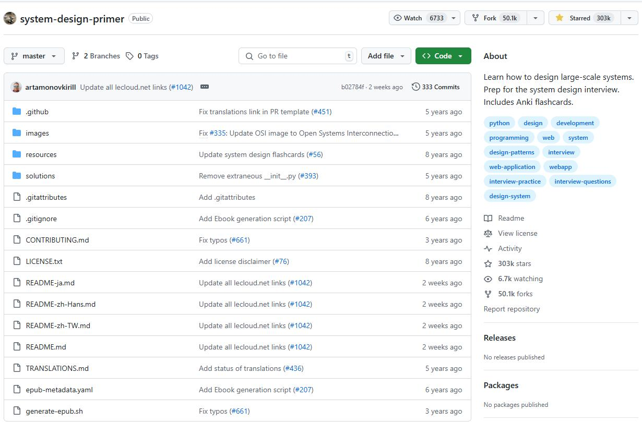
System Design Primer
A broad guide to scalable architecture, trade-offs and interview questions.
Study the repository
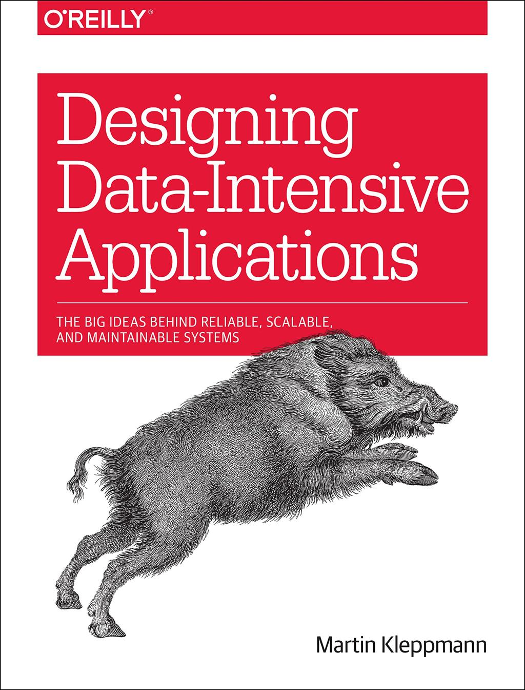
Designing Data-Intensive Applications
Study storage engines, replication, partitioning, transactions and stream processing. The book is paid, but its concepts are foundational.
Book and author resources

Apache Kafka documentation
Use the official documentation for brokers, topics, partitions, consumers and event streaming.
Read Kafka documentation
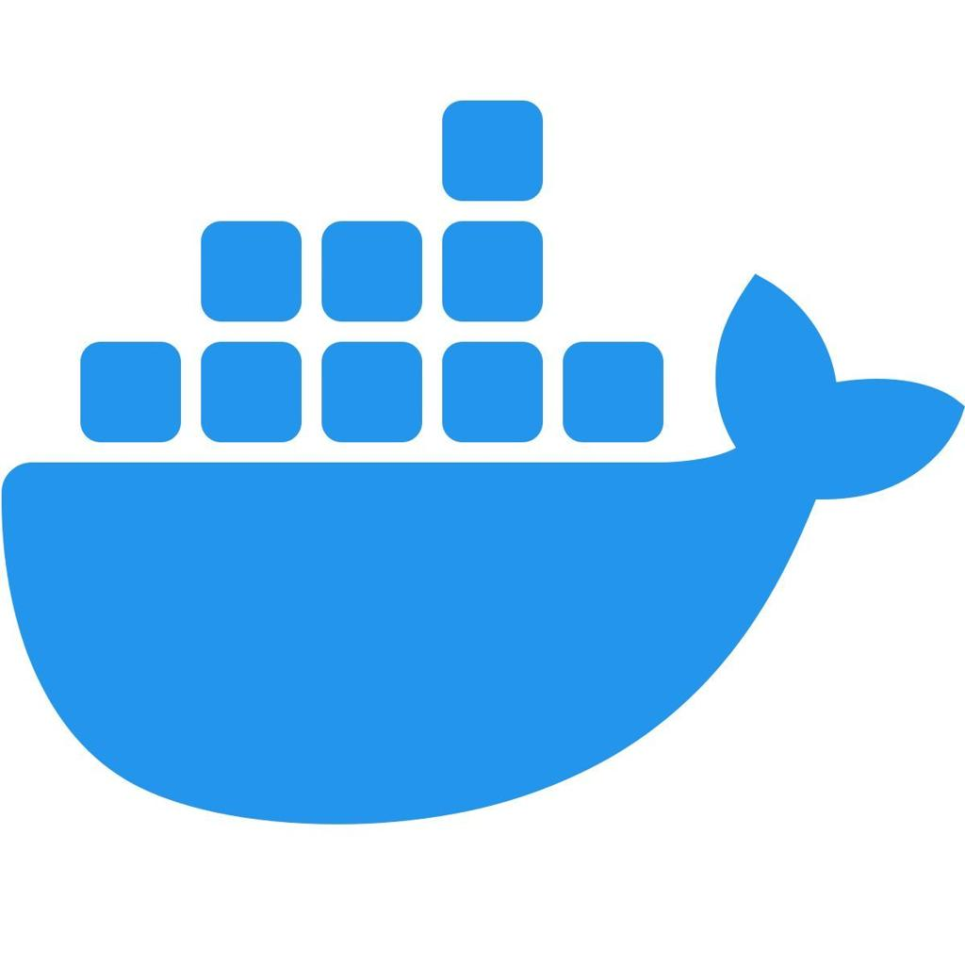
Docker documentation
Learn images, containers, volumes, networking and multi-service local environments.
Read Docker documentation
10. What makes a project interview-ready?
A project is not complete just because the code runs. Be ready to answer:
- Why did you choose PostgreSQL instead of MongoDB?
- What happens if Redis becomes unavailable?
- How would you handle duplicate events?
- What if a worker crashes halfway through a job?
- How do you prevent concurrent requests from overselling inventory?
- How would you scale from 1,000 to 1 million requests per second?
- What are the system's consistency guarantees?
- How do you recover from data loss?
- How did you test latency, throughput and failure recovery?
- What is the cost of your design, and what simpler alternative would work?
My recommendation: build Project 1 (URL Shortener) to learn HLD and LLD fundamentals, then Projects 24–26 to build data engineering depth, and finally Project 48 (Real-Time Inventory and Price Comparator) as a substantial capstone. Aim for 5–8 fully documented projects rather than 50 shallow implementations.

